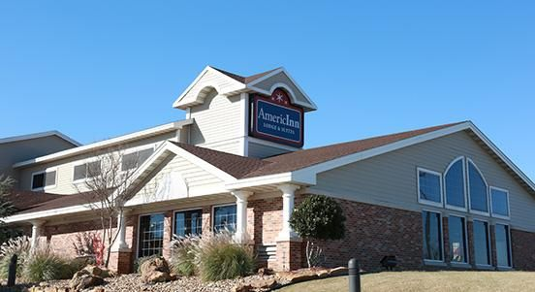 Fall Conference 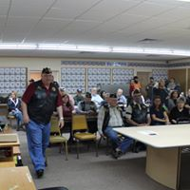
All that is missing is you
All that is missing is you
October 20, 2018
DAV Chapter 20
125 S Main St – Krebs, OK

Our Fall Conference is set to take place at DAV Chapter 20 located at 125 S Main St. Krebs, OK 74554. Registration/Sign In will begin at 8:30 a.m.
The host hotel is the AmericInn Lodge & Suites 609 S George Nigh Expressway, McAlester, OK for reservations call 918-426-1300, and mention you are with the DAV/DAVA; we have a block of King / DBL Queen rooms set aside for October 19/20th for a special room rate of $69.00

The Commander and Line Officers will be hosting a small Meet & Greet Friday evening at the Hotel with very light snacks and refreshments from 7:30 – 9 p.m.

Tentative Agenda

8:30 a.m. Registration / Sign In
9:00 a.m. Commanders Welcome Remarks
9:15 a.m. Introduction and remarks from the new Supervisor / Assistant Supervisor
NSO Muskogee Office
10:30 a.m. Guest Speaker AARP (Home Fit Guide and Family Caregiving)
11:00 a.m. CMDR/Line Officer briefings/updates
12:00 1:30 p.m. Lunch (On your own)

1:30 p.m. SEC Opening and Executive Session

DAV Auxiliary
SEC
October 20, 2018

The Auxiliary State Executive Committee meeting is set to take place at the First United Methodist Church located at 1508 S 13th St. McAlester, OK 74501. Registration will begin at 9:00 a.m. with the SEC commencing at 9:30 a.m.
The host hotel is the AmericInn Lodge & Suites 609 S George Nigh Expressway, McAlester, OK for reservations call 918-426-1300, and mention you are with the DAV/DAVA; we have a block of King / DBL Queen rooms set aside for October 19/20th for a special room rate of $69.00

